**Homework 5**

**Paper and Pencil problem:**

*5.3/ In §5.1 Introduction we discuss the devious secretary Bob having an automatic means of generating many messages that Alice would sign, and many messages that Bob would like to send. By the birthday problem, by the time Bob has tried a total of 2^32 messages, he will probably have found two with the same message digest. The problem is, both may be of the same type, which would not do him any good. How many messages must Bob try before it is probable that he'll have messages with matching digests, and that the messages will be of opposite types?*

According to the description, Bob is generating 232 messages of each type and looking for a match between the two lists. The probability that a given Type II message has the same message digest as one the 232 Type I messages is about 232/264 = 1/232 , so it is likely that one of the 232 Type II messages matches one the 232 Type I messages.

*5.4/ In §5.2.4.2 Hashing Large Messages, we described a hash algorithm in which a constant was successively encrypted with blocks of the message. We showed that you could find two messages with the same hash value in about 2^32 operations. So we suggested doubling the hash size by using the message twice, first in forward order to make up the first half of the hash, and then in reverse order for the second half of the hash. Assuming a 64-bit encryption block, how could you find two messages with the same hash value in about 2^32 iterations? Hint: consider blockwise palindromic messages.*

The digest size will remain 64 bits. Therefore, the iterations will remain the same, and if a palindrome exists within the message space, then the message will be the same forward and backward, leading to a collision when the two messages are hashed.

*5.14 - For purposes of this exercise, we will define random as having all elements equally likely to be chosen. So, a function that selects a 100-bit number will be random if every 100-bit number is equally likely to be chosen. Using this definition, if we look at the function "+" and we have two inputs, x and y, then the output will be random if at least one of x and y are random. For instance, y can always be 51, and yet the output will be random if x is random. For the following functions, find sufficient conditions for x, y, and z under which the output will be random:*

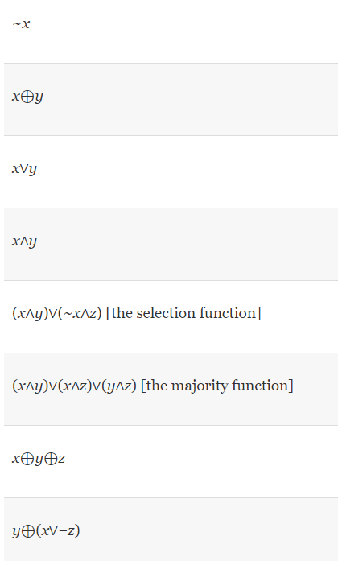

* ~ x : x is random, y & z are independent
* x  y: either x or y or both are random, and they differ in at least one bit position in their binary representation, z is independent.
* x  y: either x or y or both are random and unequal to each other in at least one bit position in their binary representation, z is independent.
* x  y: either x or y or both are random and unequal to each other and both have 1 in at least one bit position in their binary representation, z is independent.
* ( x  y )  ( ~x  z ): either x and y are different so as to obtain a non-zero value in the left-hand side of the function or ~x and z differ so as to get a unique output for the overall OR function.
* ( x  y )  ( x  z )  ( y  z ): either one of x or y or z is different in at least one bit position in their binary representation.
* x  y  z: either two of the three are different in at least one bit position in their binary representation.
* y  ( x  -z ): either of x or ~z is different so as to get the combination on the right-hand side different to y, in at least one bit position in their binary representation.

*6.2. In section §6.4.2 Defenses Against Man-in-the-Middle Attack, it states that encrypting the Diffie-Hellman value with the other side’s public key prevents the attack. Why is this the case, given that an attacker can encrypt whatever it wants with the other side’s public key?*

The hacker will not be able to decrypt the Diffie Helman values. Because of this, he will not be able to compute the shared secrets.

*6.8/ Suppose Fred sees your RSA signature on m1 and on m2, How does he compute the signature on each of the m1jmod n, m1-1mod n, m1*m2 modn, and in general m1j*m2k mod n (for arbitrary integers and k)?*

Let’s use S1 and S2 for the given signatures of m1 and m2.

S1 = m1d/k mod n

S2 = m­2d/k mod n

The signature of m1j = s1j mod n, because (m1j)d mod n = (m1d)j mod n. This means that assuming there’s a multiplicative inverse we can use the equation:

* (m1-1) = s­1-1 mod n assuming m1-1 and m2-1 exist.

When calculating the signatures m1*m2 it would be written as s1*s­2 mod n.

Therefore, in order for Fred to calculate the signature (assuming there j and k are arbitrary integers) m1j*m2k

(m1j*m2k) = s1j * s2k mod n.

**Task 1: Generating Message Digest and MAC:**

For this task, I created a file named “task1.txt” and used *openssl dgst* command to generate hash value for the file. I used three algorithms which are MD5, SHA-1, SHA-256. The result can be seen below:

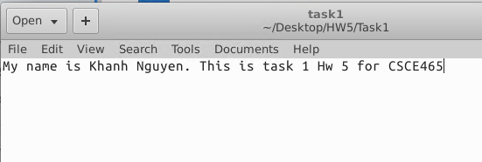

Content of task1.txt

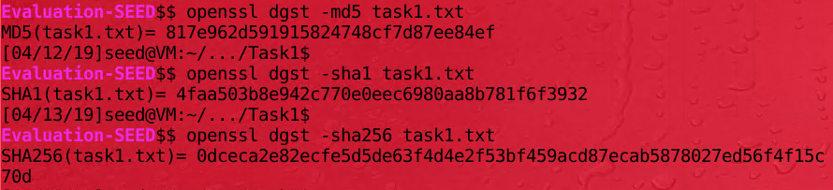

Results of hashing with 3 different techniques

The length of hash value for each technique is different. For MD5, the hash value has 32 characters, in other words, hash value of MD5 is 128 bits. For SHA-1, it resulted in 40 character long, so the hash value of SHA-1 is 160 bits. Similarly, SHA-256 has the longest hash value, which is 256 bits.

**Task 2: Keyed Hash and HMAC:**

For task 2, I used the same file in task 1. I used different keys (‘abc’, ‘abcd’, and ‘abcdefgh’) to generate hash values for the file using different techniques HMAC-MD5, HMC-SHA256, HMAC-SHA1. The results can be seen below:

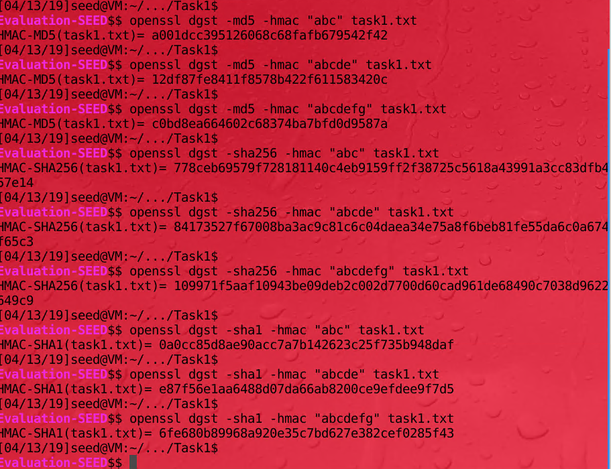

Keyed hash with different key lengths and techniques

From the results, we can see that for each of the techniques, the keyed hash values have the same length no matter how long the key is. Therefore, I don’t think we have to use the key with fixed size in HMAC.

**Task 3: The Randomness of One-way Hash:**

In this task, I created a file task3.txt then generated hash values for it using MD5 and SHA256 techniques. Then I modified one bit of the file using ghex. After that I generated MD5 and SHA256 hash value for the modified file. The results can be observed below:

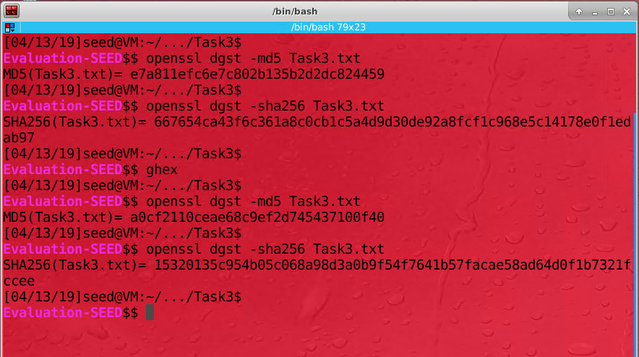

Task 3 results

From the result, we can see that changing one bit of the file can result in a totally different hash value. There are only 3 bits got repeated in MD5 and 1 bit got repeated in SHA256.

**Task 4: Hash Collision-Free Properties:**

For this task, I used Python with built-in hashlib library to implement and experiment the two properties of hashing: Collision-Free Property and One-Way Property. The random strings I generated range from 1 to 26 characters. I used MD5 technique to generate hash values for random generated strings.

* For Collision-Free Property: I used a dictionary to store all the generated strings and hash values. Then I checked if the newly generated hash value already existed in the dictionary. If the dictionary already contains the hash value that its first 6 hex bits are the same as different other hash values’s, then the Collision-Free Property has been cracked.
* For One-Way Property: I created a fixed string “Khanh Nguyen task 4” and generated its hash value. After that I generated other random strings and compared their hash values with the original one until I found collision in the first 6 hex bits.

The code is shown below:

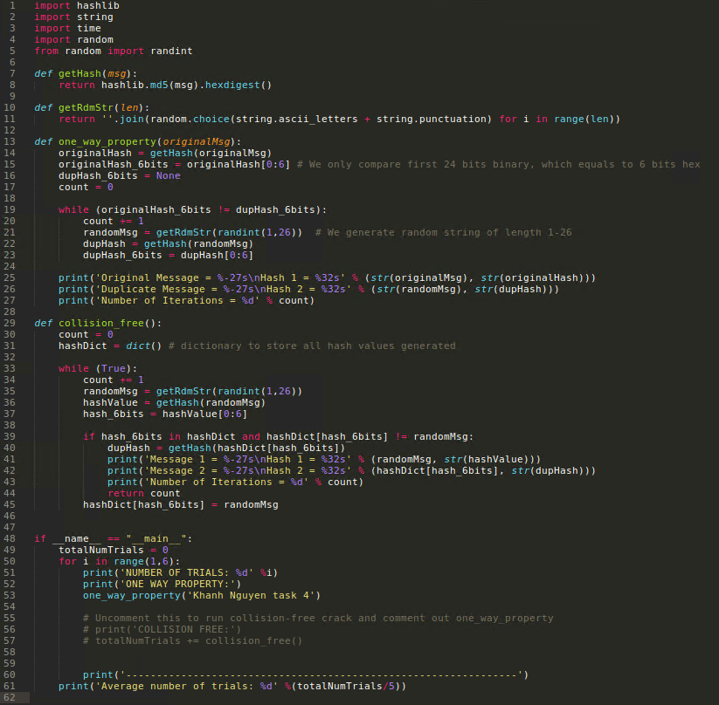

Task 4 code for Collision Free Property and One Way Property

For each property, I ran cracking code 5 times to find the average number of trials. The result is shown below:

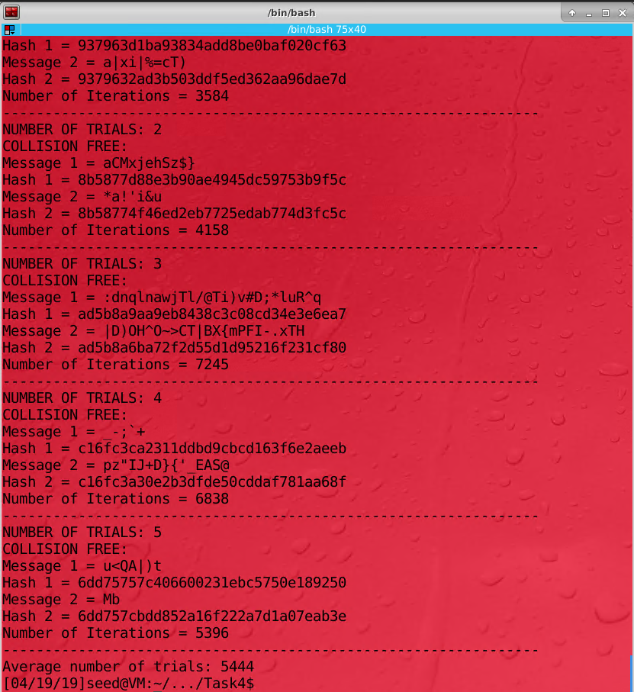

Result for breaking collision free property

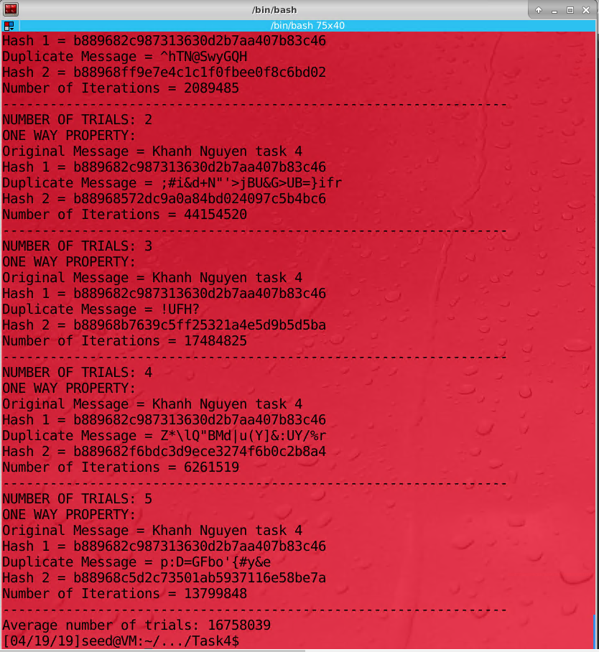

Result for breaking One-Way Property

1. From the screenshots above, I ran the code 5 times to calculate the average number of trials for Collision Free Property. The average number of trials for breaking Collision Free Property (where I had to find two messages that have same hash values) is 5,444.
2. From the screenshots above, I ran the code 5 times to calculate the average number of trials for One Way Property. The average number of trials for breaking One Way Property (where I had to find messages that have same hash values as known message’s hash value) is 16,758,039 which is much larger than the result from breaking Collision Free Property.
3. Based on my observation, the One Way Property is much harder to break and took me much longer time to execute the code ( much more number of iterations). Collision Free Property is much easier to break and the code ran much faster.
4. For the One Way Property, we are finding the matching hash value that are from 166 hex bits (6 because we’re only comparing the first 6 hex bits or in other words, 24 binary bits). The probability therefore is 1/16,777,216 which is very closed to the number that I got from my experiment above.

For the Collision Free Property, we are finding the two matching hash values from 166  = 16,777,216 combinations. Each time we generate a hash, we add it to a dictionary and keep comparing them with the new ones. Therefore, the probability for finding matching hash values is much higher.

Considering the scenario of birthday attack, we are having a large number of inputs – 224, to have the at least 0.5 probability of hash collision, we can hash at least 224/2 = 4096 messages. Therefore, it can be said that the probability to break to collision free property is approximately 1/4096.

**Task 5: Performance Comparison: RSA versus AES:**

**These below are the steps for encrypting and decrypting message using 1024 bit RSA:**

Before applying the encryption, I created a file ‘message.txt’ that contain 16-byte text like below:

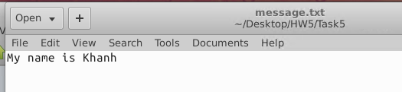

To encrypt the file using RSA method, first I need to generate the 1024 bit RSA private key:

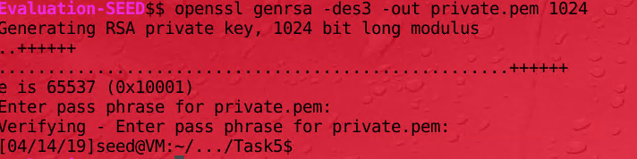

Next, I generated the public key associated the with private key:

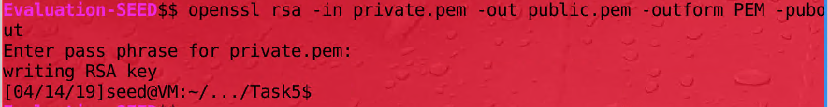

After that, I encrypt the file with the public key created:

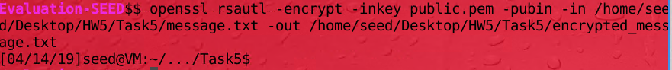

It generated the RSA encrypted file with the content shown below:

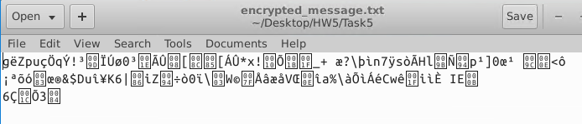

Now, I decrypted the file with the private key generated previously:



And the content of the decrypted file is shown below:

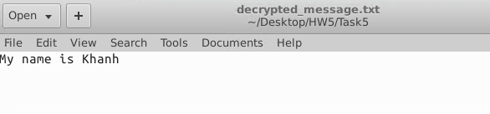

**These steps below are for encrypting file using 128-bit AES key:**

For this part, I used the same file message.txt. I encrypted the file using 128-bit AES CBC:



It resulted in the file below:

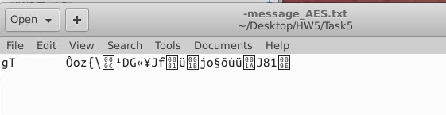

Since the encrypting for both AES and RSA is pretty fast, I wrote a shell code to run each of the command 1000 times. After that I calculate the average runtime for each:

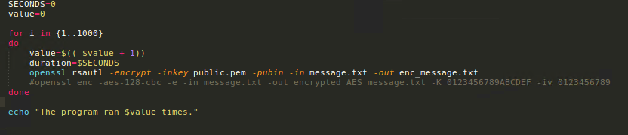

Shell code to run RSA and AES encryption

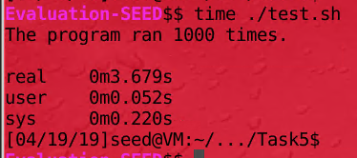

Result for RSA ran with shell code

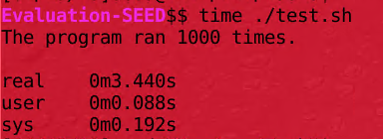

Result for AES ran with shell code

From the result above, we can see that their runtime are pretty similar. RSA took averagely 3.679 milliseconds for each operation and AES took averagely 3.440 milliseconds for each operation (I ran 1000 times each method). There is no significant difference between the two.

After that, I ran the benchmarking for RSA and AES:

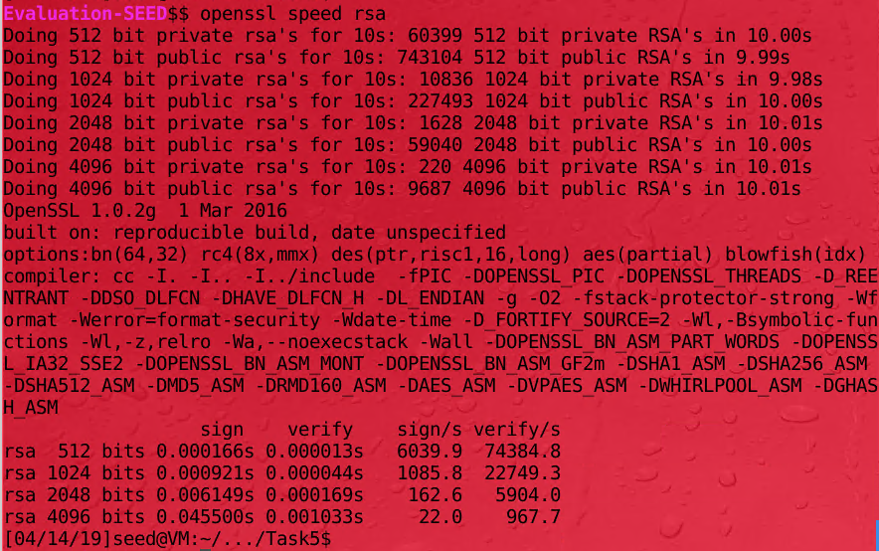

Benchmarking for RSA

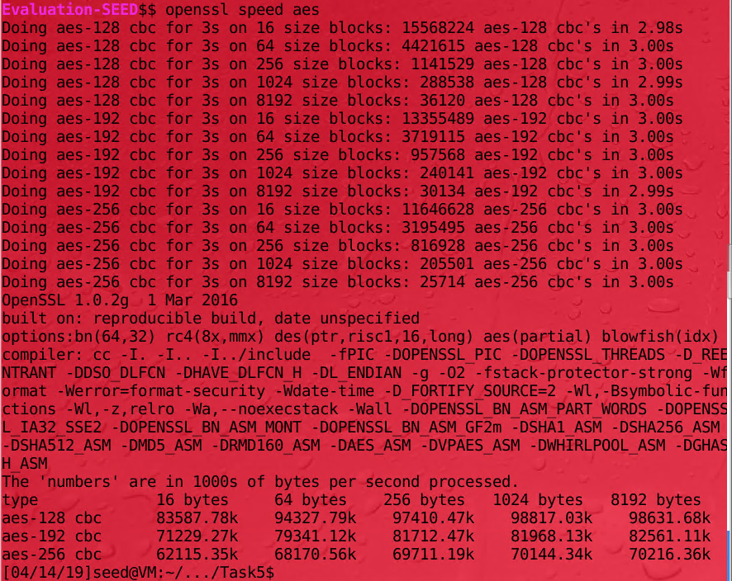

Benchmarking on AES

The times between my trials of both RSA and AES are similar to the openssl speed tests

**Task 6: Create Digital Signature:**

For this task I created the example.txt file that has content below:

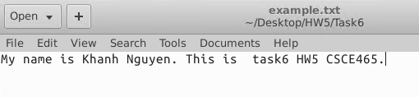

The steps demonstrate how I used SHA256 to hash and signed the file:

First, I generate the private key using RSA algorithm:

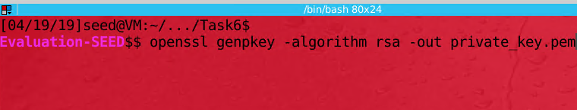

After that, I generate the public key associated with the private key:

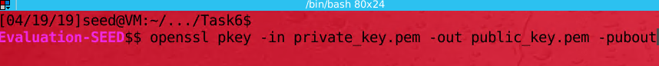

This is the content of public key:

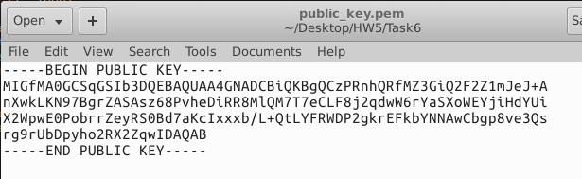

Next, I generated the hash value and signed the plain text example.txt using SHA256:



To verify the file, I used the following command:



It shows that the Verification is complete.

To observe that if the digital signature can still work if I modify the file, I change the content of the example.txt a little as shown below:



Original content

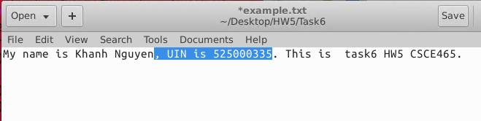

Modified content

After that I ran the code to verify the signature again but I the verification falied.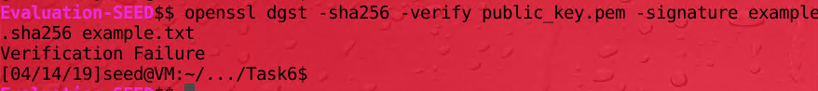

It shows that if the content of the file changes, the public key private key can also change. It leads to the result of verification failure. Digital signatures are important in security because they ensure integrity and non-repudiation. Using this, we can tell if a document was tampered, and we know not to use it. Furthermore, digital signatures help ensure delivery and helps track who interacts with the information.